SET-04

7.Write a Pandas program to create a Pivot table and find the maximum and minimum
sale value of the items.
Code:
import pandas as pd
df = pd.read_csv("sales.csv")
pivot = pd.pivot_table(df,
values="Sale",
index="Item",
aggfunc=["max","min"])
print(pivot)
Output:
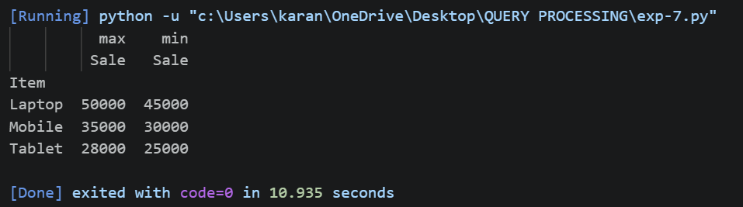
8.Write a Pandas program to create a Pivot table and find the item wise unit sold.
Code:
import pandas as pd
df = pd.read_csv("sales.csv")
pivot = pd.pivot_table(df,
values="Units",
index="Item",
aggfunc="sum")
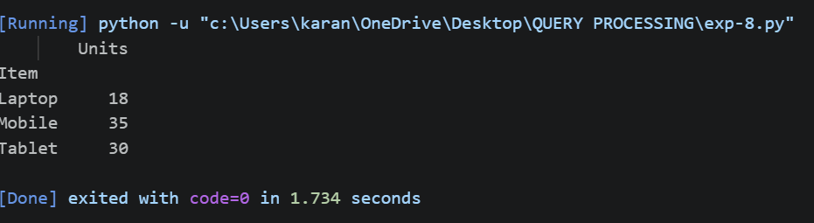
print(pivot)
Output:

